Gini 80:20
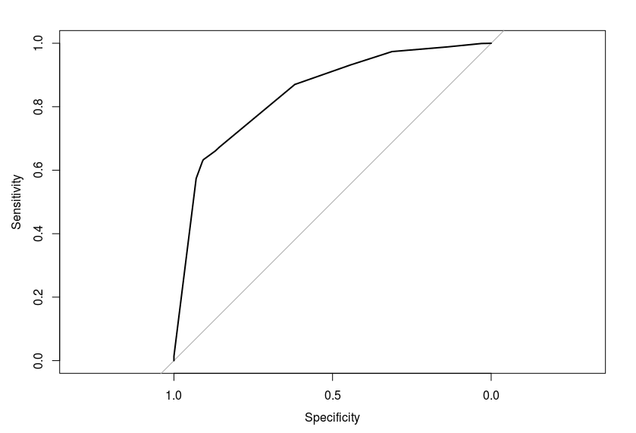

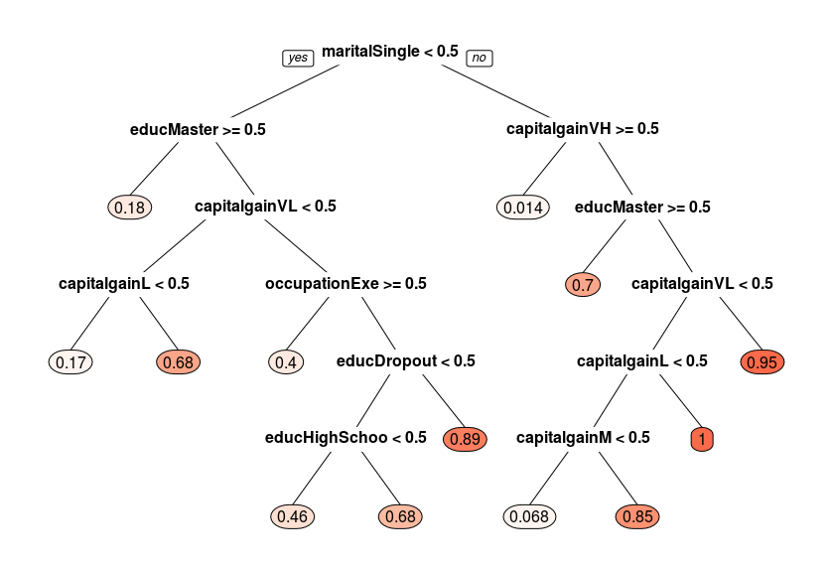

Confusion Matrix

pred 0 1
1 1299 3021
Accuracy 0.3006944
Recall 0.3006944
Precision 1
F-Score 0.4623599
AUC 0.8421367

Gini 10-fold
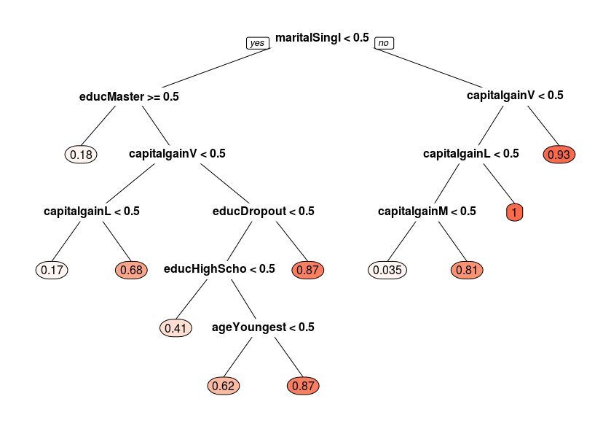
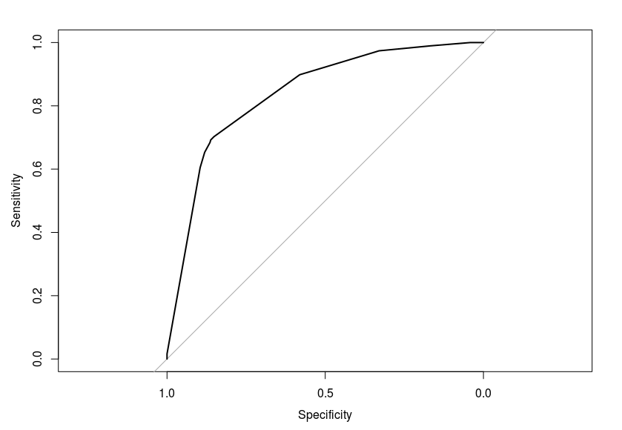

pred 0 1
0 727 312
1 525 2756
Accuracy 0.80625
Recall 0.6997113
Precision 0.5806709
F-Score 0.6346574
AUC 0.8394025

Ent 80:20
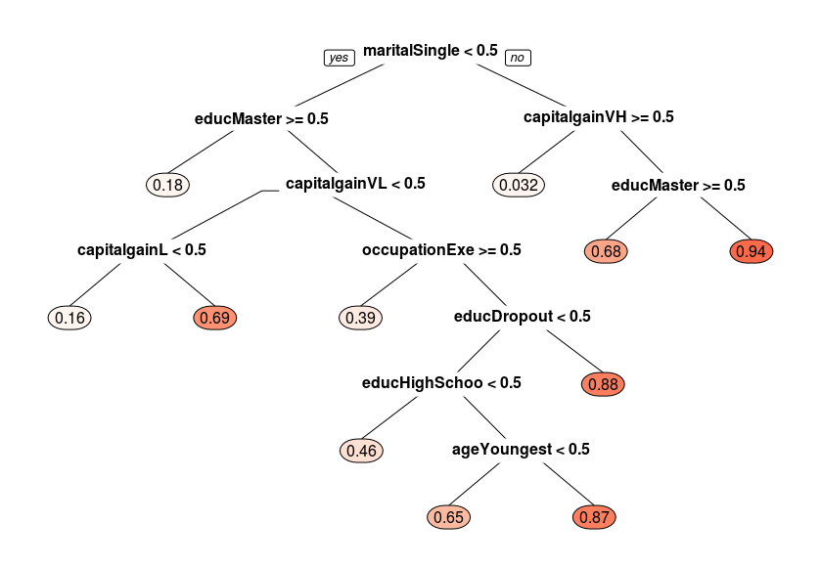
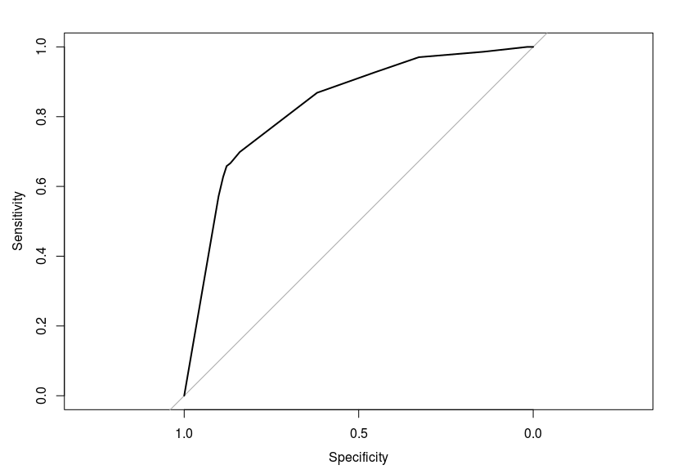

pred 0 1
0 805 397
1 495 2623
Accuracy 0.7935185
Recall 0.6697171
Precision 0.6192308
F-Score 0.6434852
AUC 0.8325209

ent 10-fold
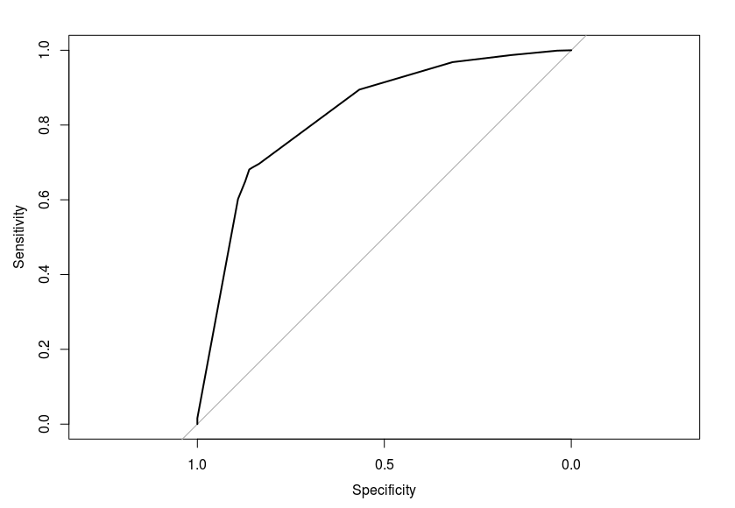
pred 0 1
0 735 318
1 562 2705
Accuracy 0.7962963
Recall 0.6980057
Precision 0.5666924
F-Score 0.6255319
AUC 0.8296176

naive Bayes 80:20
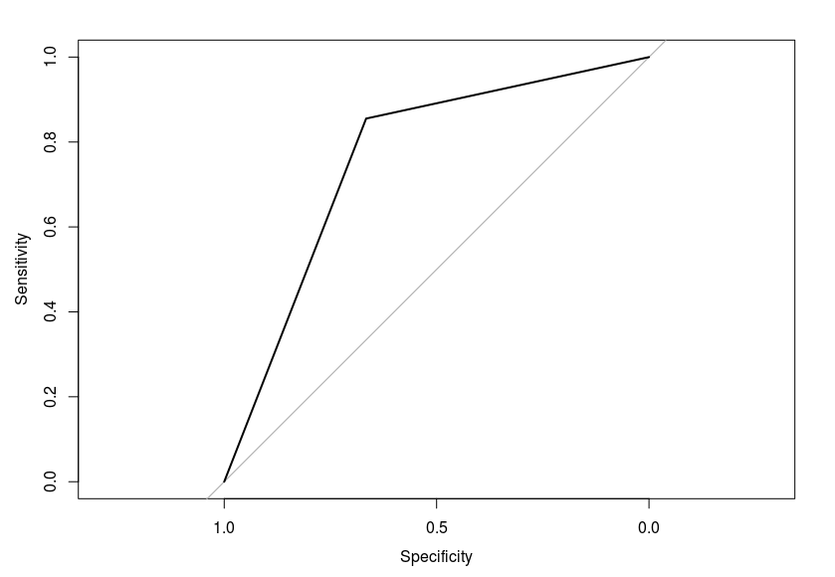
pred High Low
High 857 439
Low 430 2594
Accuracy 0.7988426
Recall 0.6612654
Precision 0.6658897
F-Score 0.6635695
AUC 0.7605742

naive bayes 10-folds
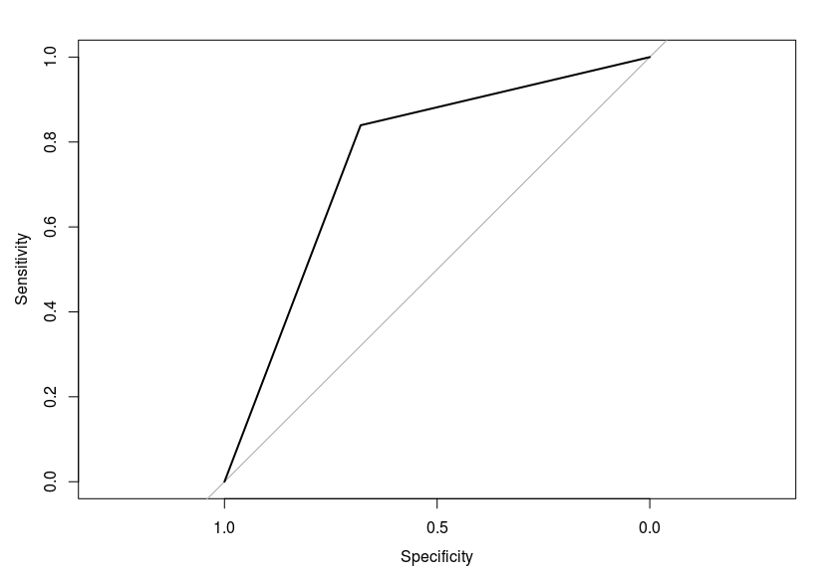
pred High Low
High 875 487
Low 412 2546
Accuracy 0.7918981
Recall 0.6424376
Precision 0.6798757
F-Score 0.6606267
AUC 0.7596543

nnet 1hidden layer 80:20
technical difficulties: took 1000 records
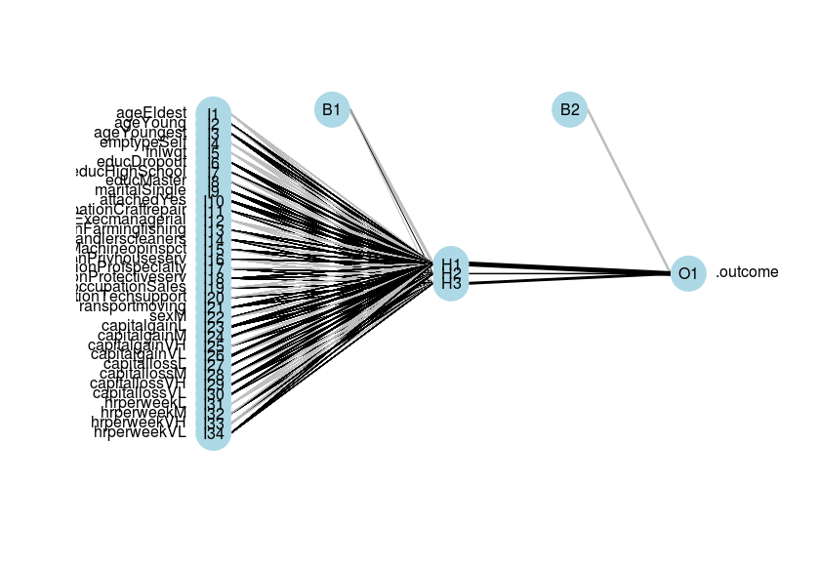
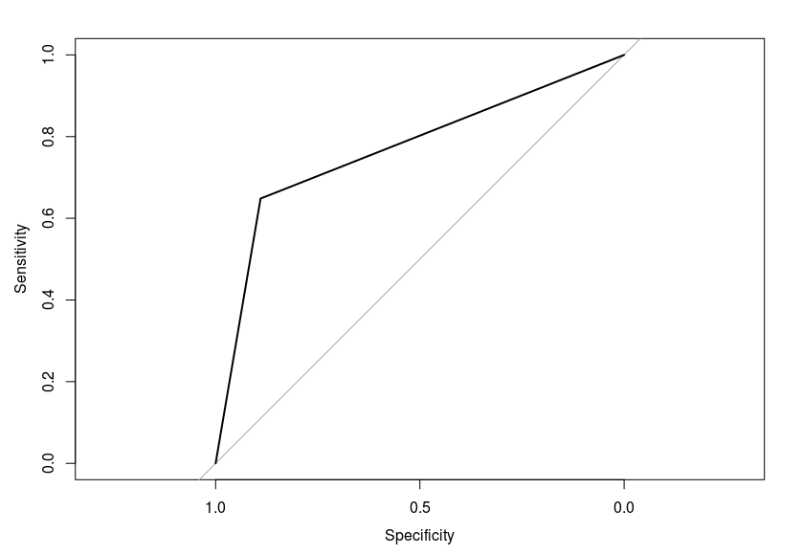
predicted High Low
High 59 23
Low 32 186
Accuracy 0.8166667
Recall 0.7195122
Precision 0.6483516
F_Score 0.6820809
AUC 0.7691519

nnet 1 hidden layer 10-fold
technical difficulties: took 1000 records
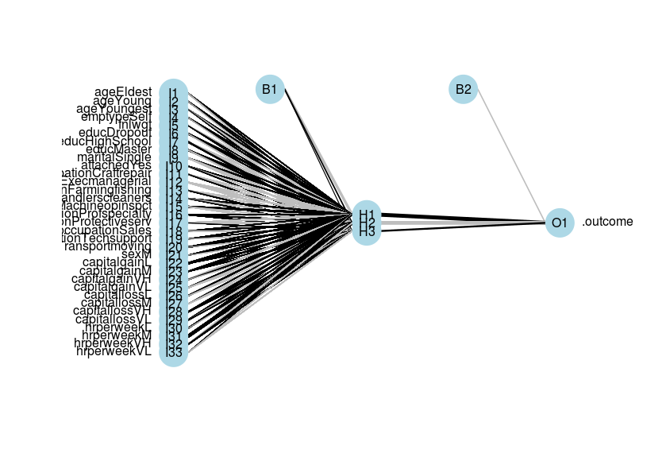
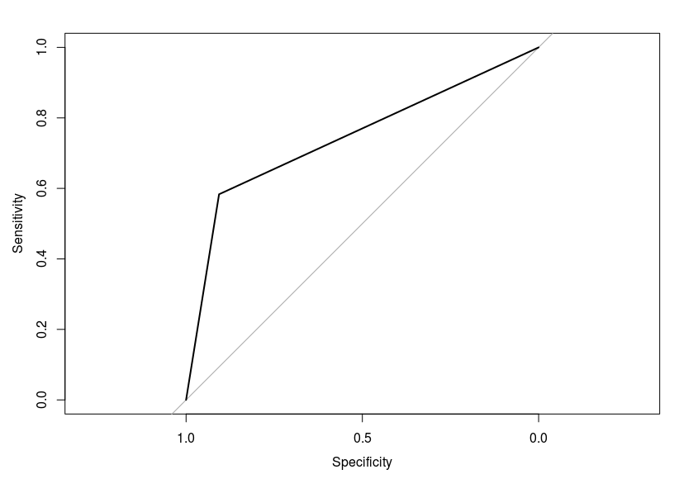

predicted High Low
High 35 13
Low 25 126
Accuracy 0.8090452
Recall 0.7291667
Precision 0.5833333
F_Score 0.6481481
AUC 0.7449041
neuralnet 80:20
technical difficulties: took 1000 records
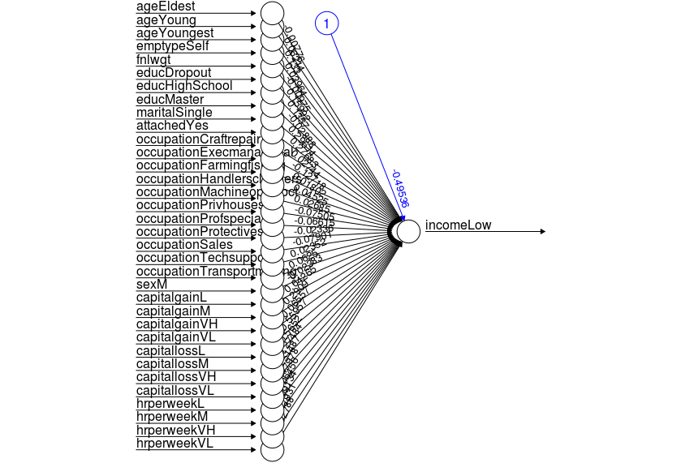

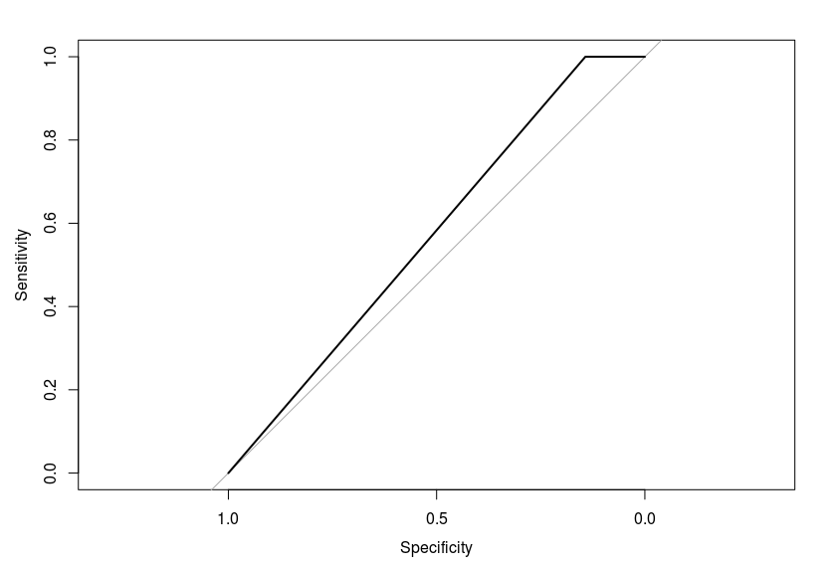

predicted 0 1
0 10 0
1 49 141
Accuracy 0.755
Recall 1
Precision 0.1694915254
F_Score 0.2898550725
AUC 0.5847457627

ann folds
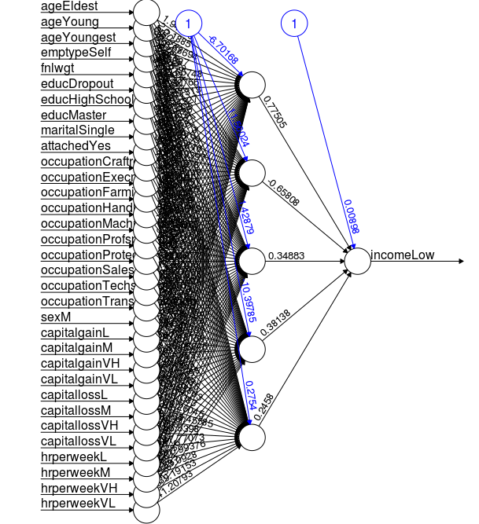

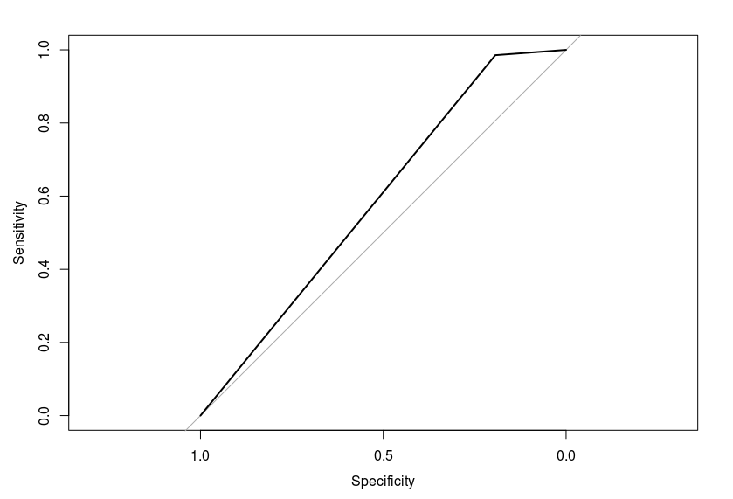

predicted 0 1
0 6 1
1 25 68
Accuracy 0.74
Recall 0.8571428571
Precision 0.1935483871
Precision 0.1935483871
AUC 0.5895278167

in 80:20 sampling, GINI has highest AUC
in 10-folds, GINI has highest AUC

classes=2

size max_diss av_diss isolation
[1,] 15508 127832 46042.08 0.8968716
[2,] 6093 1195515 59702.55 8.3877542

db<-dbscan(d,eps=661673,minPts = 6093)
DBSCAN clustering for 21601 objects.
Parameters: eps = 661673, minPts = 6093
The clustering contains 1 cluster(s) and 1 noise points.

0 1
1 21600

Available fields: cluster, eps, minPts

Noise=1

kmeans with k=1
SSE =0
kmeans with k=2
SSE =58.9
kmeans with k=1
SSE =79

Silhouette Coefficient:
PAM
0.09793531588 0.05836528851
0.08016837359
CLARA
0.14558047955 0.05815519407
0.1177633433

